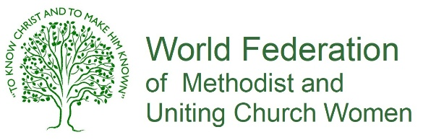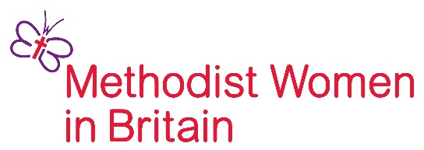

HELEN KIM MEMORIAL SCHOLARSHIP
LEADERSHIP DEVELOPMENT TRAINING PROGRAMME
FOR YOUNG WOMEN 2026–2031

APPLICATION FORM – STAGE 1

Surname………………………………………………........ First / Other Names ………………….………………………………………….....………
Title: Mrs Miss Ms Dr Rev Other …………………………………………………………..............
Date of Birth: ………………………………………………………… Email: ……………………………………………………………………………........

Address: …………………………………………………………………………………………………………………………………………………………............
City / Town: …………………………………………………………................ County: …………………………………………………………….......
Postcode: …………………………………………………. Email address: .....................................................................................
Telephone / mobile: ……………………………………………….....................................................................................................
Are you a committed member of a Methodist, United or Uniting Church? Yes No

Why are you interested in becoming a Helen Kim Memorial Scholar?
…………………………………………………………………………………………………………………………………………………………………………….....
…………………………………………………………………………………………………………………………………………………………………………….....
…………………………………………………………………………………………………………………………………………………………………………….....
…………………………………………………………………………………………………………………………………………………………………………….....
…………………………………………………………………………………………………………………………………………………………………………….....
…………………………………………………………………………………………………………………………………………………………………………….....

How are you involved in the Methodist church ? In particular, please show how you are involved in worship, justice and leadership. Please include anything you are doing beyond, as well as within, the church. ………………………………………………………………………………………………………………………………………………………………………….......
...................................................…………………………………………………………………………………………………………………………...... ………………………………………………………………………………………………………………………………………………………………………………..
………………………………………………………………………………………………………………………………………………………………………………..
Are you a person who has shown leadership abilities? What gifts, graces and interests do you particularly bring to the role that would contribute to the development of your church leadership?
……………………………………………………………………………………………………….…………………………………….……………………………....
…………………………………………………………………………………………………………………………………………………………………………….....
…………………………………………………………………………………………………………………………………………………………………………….....
…………………………………………………………………………………………………………………………………………………………………………….....
Are you involved in women’s issues? Yes No If yes, in what capacity? .…………………………………………….......
...................................................…………………………………………………………………………………………………………………………......

How will you use the skills and knowledge acquired through the Helen Kim Leadership Training Programme?
…………………………………………………………………………………………………………………………………………………………………………….....
…………………………………………………………………………………………………………………………………………………………………………….....
…………………………………………………………………………………………………………………………………………………………………………….....
…………………………………………………………………………………………………………………………………………………………………………….....
…………………………………………………………………………………………………………………………………………………………………………….....
…………………………………………………………………………………………………………………………………………………………………………….....
…………………………………………………………………………………………………………………………………………………………………………….....

Are you a student? Yes No
What are your main subjects? ………………………………………………………………………………………………………………………….........
Qualifications already held? ……………………………………………………………………………………………………………………………..........
.............................................……………………………………………………………………………………………………………………………..........

Are you in employment? Yes No
What is your work? ………………………………………………………………....................................................................................
Where are you employed? ……………………………………………………………...........................................................................

Signature of applicant: ……………………………………………………………………………………………

Signature of nominating person: …………………………………………...........……………………..

Signature of your Church Minister: …………………………………………………..........…………..

DEADLINE FOR APPLICATIONS: Monday 29th September 2025
Return completed form by email: communications.mwib@gmail.com

