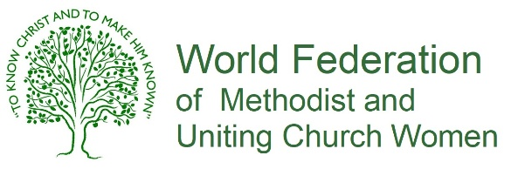 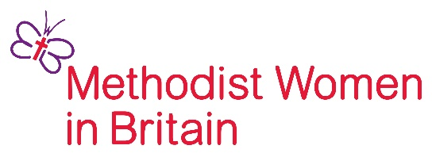

HELEN KIM MEMORIAL SCHOLARSHIP

LEADERSHIP DEVELOPMENT TRAINING PROGRAMME

FOR YOUNG WOMEN 2026–2031

APPLICATION FORM – STAGE 1

Surname………………………………………………........ First / Other Names ………………….………………………………………….....………

Title:🞎Mrs 🞎 Miss 🞎 Ms 🞎 Dr 🞎 Rev 🞎 Other …………………………………………………………..............

Date of Birth: ………………………………………………………… Email: ……………………………………………………………………………........

Address: …………………………………………………………………………………………………………………………………………………………............

City / Town: …………………………………………………………................ County: …………………………………………………………….......

Postcode: …………………………………………………. Email address: .....................................................................................

Telephone / mobile: ……………………………………………….....................................................................................................

Are you a committed member of a Methodist, United or Uniting Church? Yes 🞎 No 🞎

Why are you interested in becoming a Helen Kim Memorial Scholar?

…………………………………………………………………………………………………………………………………………………………………………….....

…………………………………………………………………………………………………………………………………………………………………………….....

…………………………………………………………………………………………………………………………………………………………………………….....

…………………………………………………………………………………………………………………………………………………………………………….....

…………………………………………………………………………………………………………………………………………………………………………….....

…………………………………………………………………………………………………………………………………………………………………………….....

How are you involved in the Methodist church ?  In particular, please show how you are involved in worship, justice and leadership. Please include anything you are doing beyond, as well as within, the church. ………………………………………………………………………………………………………………………………………………………………………….......

...................................................…………………………………………………………………………………………………………………………...... ………………………………………………………………………………………………………………………………………………………………………………..

………………………………………………………………………………………………………………………………………………………………………………..

Are you a person who has shown leadership abilities? What gifts, graces and interests do you particularly bring to the role that would contribute to the development of your church leadership?

……………………………………………………………………………………………………….…………………………………….……………………………....

…………………………………………………………………………………………………………………………………………………………………………….....

…………………………………………………………………………………………………………………………………………………………………………….....

…………………………………………………………………………………………………………………………………………………………………………….....

Are you involved in women’s issues? Yes 🞎 No 🞎 If yes, in what capacity? .…………………………………………….......

...................................................…………………………………………………………………………………………………………………………......

How will you use the skills and knowledge acquired through the Helen Kim Leadership Training Programme?

…………………………………………………………………………………………………………………………………………………………………………….....

…………………………………………………………………………………………………………………………………………………………………………….....

…………………………………………………………………………………………………………………………………………………………………………….....

…………………………………………………………………………………………………………………………………………………………………………….....

…………………………………………………………………………………………………………………………………………………………………………….....

…………………………………………………………………………………………………………………………………………………………………………….....

…………………………………………………………………………………………………………………………………………………………………………….....

Are you a student? Yes 🞎 No 🞎

What are your main subjects? ………………………………………………………………………………………………………………………….........

Qualifications already held? ……………………………………………………………………………………………………………………………..........

.............................................……………………………………………………………………………………………………………………………..........

Are you in employment? Yes 🞎 No 🞎

What is your work? ………………………………………………………………....................................................................................

Where are you employed? ……………………………………………………………...........................................................................

Signature of applicant: ……………………………………………………………………………………………

Signature of nominating person: …………………………………………...........……………………..

Signature of your Church Minister: …………………………………………………..........…………..

**DEADLINE FOR APPLICATIONS: Monday 29th September 2025**

Return completed form by email: communications.mwib@gmail.com